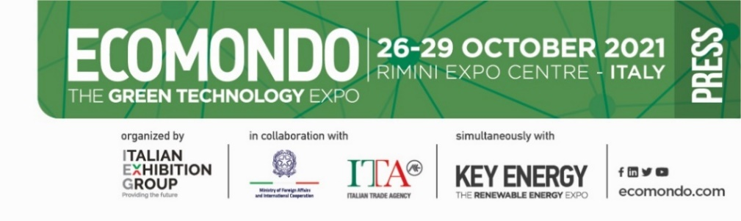

press release
(English translation)

IEG: at Ecomondo and Key Energy 2021
focus on the green challenges of the African and Europe continent.

African embassies and companies, associations and buyers from Europe and Africa
have confirmed their interest, an enrichment of know-how and tangible business opportunities

Rimini (Italy) 19 July 2021 – A driving force for environmental business and an ecological transition accelerator: four days of business and know-how exchange with top experts from the European Commission, innovators, international and national authorities, the world of science and university, decision makers and investors. All gathered from 26th to 29th October, at Rimini Expo Centre in Italy, for Ecomondo (24th edition) and Key Energy (14th edition). “These two shows of ours,” explained Corrado Peraboni, CEO of IEG- Italian Exhibition Group, “are green economy and renewable energy leaders in the Euro Mediterranean basin. They present products and compare projects for the global green challenges that every country has been called upon to resolve, particularly those on the African and European continent.”

As IEG’s Green&Technology group exhibition manager, Alessandra Astolfi, adds: “The African embassies of Algeria, Egypt, Morocco, Tunisia, Ruanda and Kenya, to name but a few, will be represented at the trade shows, as well as companies, associations and buyers from the aforementioned countries and from Europe, to further their know-how, develop networking and finalize business agreements”.
The 2021 edition of Ecomondo and Key Energy will ignite an authentic debate and business platform, further enriched by one-to-one meetings that buyers and companies will be able to organize even prior to the event.

Besides the exhibition area, which will occupy all the Expo Centre and is the core of Ecomondo and Key Energy, the two shows will also feature 150 seminars and conferences – many of which international and in English – officiated by professor Fabio Fava and Gianni Silvestrini as heads of their respective Scientific and Technical Committees. The main theme, the Mediterranean basin: as part of the BlueMed Pilot initiative and with the participation of the European Commission, the event will illustrate the production and plastic recycling strategies for a clean sea and for recovering degenerated ecosystems and habitats. Other events will deal with the topic of circular bio-economy proposed by the Mission Soil Health and Food Mission Board to ensure that 75% of soils are healthy by 2030, while workshops on plastic waste transformation will highlight the opportunities of pyrolysis systems as well as the legal obstacles that are still blocking these types of technologies.

For Key Energy, the opening conference will offer the chance to shed light on the opportunities for Italy linked to the PNRR, (National Recovery and Resilience Plan), on incentive policies for energy transition and the assessment of their impact on the Nation-System, while the Africa Green Growth event, in collaboration with ITA Italian Trade Agency, will directly involve institutional representatives and African associations from Kenya and Ruanda, as well as Italian companies in Sub-Saharan Africa and will highlight the future role of wind energy in the African continent’s energy mix. And, in line with the events, the electricity sector at the centre of European actions to re-launch the economy: institutions and European associations will meet with Italian interlocutors to define the best strategy to fulfil the Green Deal.

This year, running alongside Ecomondo and Key Energy, will be SAL.VE, the biennial Environmental Motor Show, organized by IEG in partnership with ANFIA (Italy’s automotive industry association), which will be exhibiting the entire range of vehicles and fittings for urban hygiene, street cleaning and solid and liquid waste collection and transportation.

The programme of events, subject to modification, is available on the following link:
https://en.ecomondo.com/events/program/events-schedule?date=2021-10-26

www.ecomondo.com
https://en.keyenergy.it

PRESS CONTACT ITALIAN EXHIBITION GROUP
Head of media relation & corporate communication: Elisabetta Vitali; press office manager: Marco Forcellini; international press office coordinator: Silvia Giorgi; media@iegexpo.it
FOCUS ON ITALIAN EXHIBITION GROUP
Italian Exhibition Group (IEG), listed on the MTA (screen-based stock exchange) organised and managed by Borsa Italiana S.p.A., has built up over the years, through its Rimini and Vicenza venues, a position of domestic leadership in the organisation of trade fairs and conferences, and has developed its foreign activities - also through joint ventures with global or local organisers, in the United States, United Arab Emirates, China, Mexico, India - which have positioned it among the leading European operators in the sector.

This press release contains forecast elements and estimates that reflect the management’s current opinions (“forward-looking statements”), particularly regarding future management performance, realization of investments, cash flow trends and the evolution of the financial structure. For their very nature, forward-looking statements have a component of risk and uncertainty, as they depend on the occurrence of future events. The effective results may differ (even significantly) from those announced, due to numerous factors, including, only by way of example: food service market and tourist flow trends in Italy, gold and jewellery market trends, green economy market trends; the evolution of raw material prices; general macroeconomic conditions; geopolitical factors and evolutions in the legislative framework. Moreover, the information contained in this release, does not claim to be complete, and has not been verified by independent third parties. Forecasts, estimates and objectives contained herein are based on the information available to the Company as at the date of this release.

