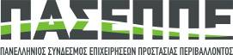
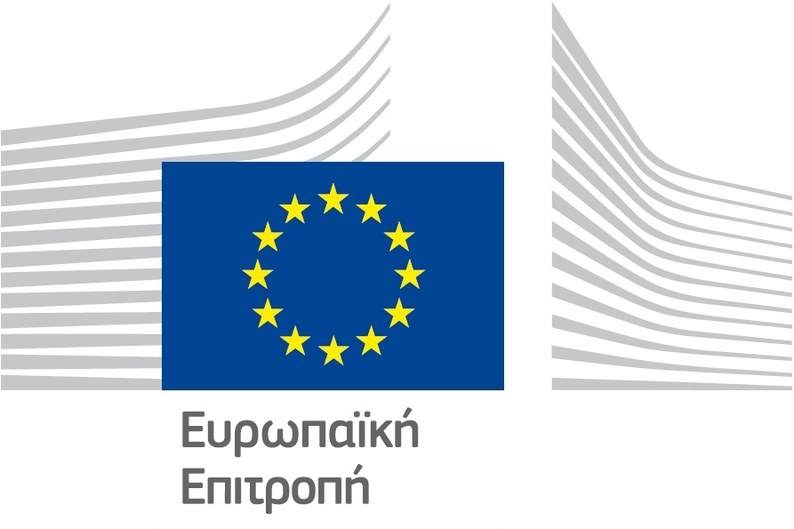

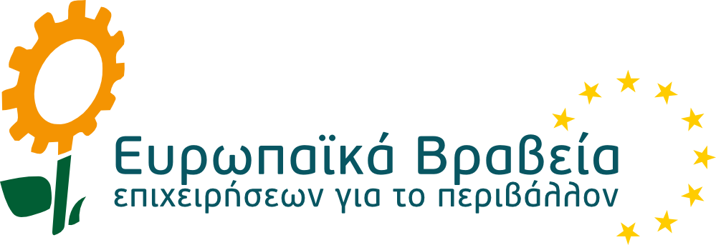

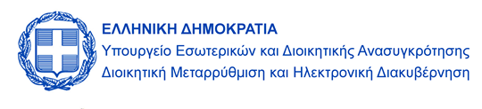
ΥΠΟ ΤΗΝ ΑΙΓΙΔΑ:

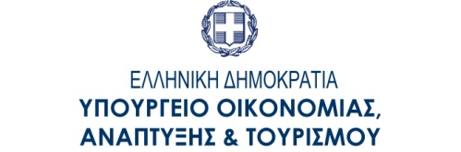
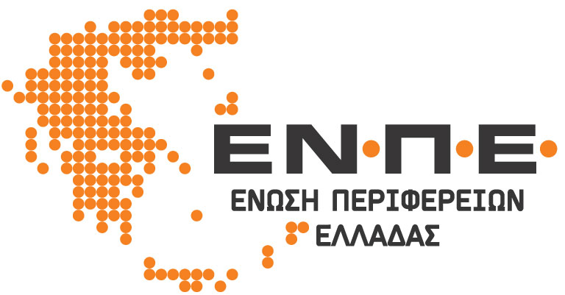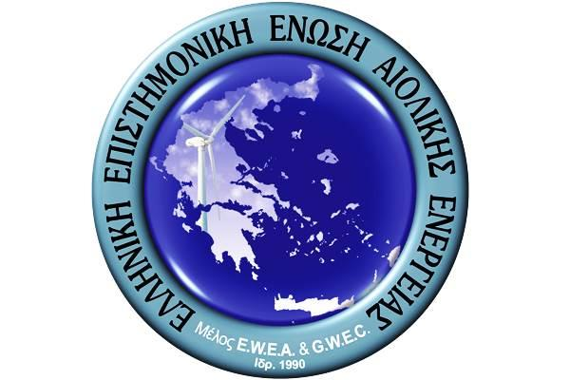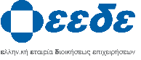

HANDBOOK

1. OVERVIEW OF THE EUROPEAN BUSINESS AWARDS FOR THE ENVIRONMENT 3
a. Aims and political context 3
b. Presentation of the Awards and Categories 4
2. WHO CAN APPLY FOR A EUROPEAN BUSINESS AWARD FOR THE ENVIRONMENT? 7
3. AWARD CRITERIA 8
4. THE EBAE CEREMONY 12
5. THE EBAE SECRETARIAT 13
a. Role and function 13
6. ENTRY FORMS 13

OVERVIEW OF THE EUROPEAN BUSINESS AWARDS FOR THE ENVIRONMENT

  - Aims and political context

The European Business Awards for the Environment (EBAE) aim to reward businesses which successfully combine innovation and economic viability with the protection of the environment.

The Awards highlight eco-innovative practices, processes and products from all sectors of business in the EU, which make a contribution to the transition to a circular economy, by reducing the environmental impact of our production and consumption, thereby enhancing nature's resilience to environmental pressures and achieving a more efficient and responsible use of natural resources.

The Awards is an essential part of the European Commission’s toolbox for promoting circular economy, eco-innovation and participation in green markets among European companies.

Protecting the environment and making the transition to a circular economy can significantly strengthen business competitiveness and also the wider economic competitiveness of Europe. Companies’ and our economies’ fate will be decided by how we face challenges like resource scarcity, how we learn to use material and energy efficiently, and by our ability to produce smarter goods that can be re-used, repaired and recycled.

On this basis, European environmental policy wants to harness but also to further encourage the excellence and commitment of companies that lead them towards creating environmentally friendly products, processes, services, technologies and business models.

EBAE therefore promote outstanding economic and environmental performances from the business world, the innovation capacity of entrepreneurs and the effective use of instruments for the provision of reliable and comparable information such as EMAS, EU Environmental Technology Verification (ETV) and the European Ecolabel.

An Award adapted to today's economic challenges

The European Business Awards for the Environment (EBAE) (formerly known as the European Better Environment Awards for Industry – EBEAFI and the European Awards for the Environment) were launched in 1987 to reward technological developments that help create a sustainable society.
Since then the EBAE continues to adapt to the evolving policy context and to support the implementation of the following major policy initiatives.

In 2010 the Commission adopted the Europe 2020 strategy for smart, sustainable and inclusive growth. The connected flagship initiatives like the 'Innovation Union' 'Resource-Efficient Europe' and the ‘Circular Economy Strategy’ ensure that innovative ideas will create growth and jobs while contributing to a transition towards a green economy.

The Eco-innovation Action Plan – which was adopted in 2011 in the context of the Innovation Union– is a tool to identify and implement measures for the deployment of key environmental technologies and eco-innovative business practices, to enhance coordination and cooperation between the EU and Member States and to generate awareness of the potential of innovative solutions.

The 2015 EU Action Plan for the Circular Economy established a programme of action with measures covering the whole cycle: from production and consumption to waste management and the market for secondary raw materials. The circular economy will boost the EU's competitiveness by protecting businesses against scarcity of resources and volatile prices, helping to create new business opportunities and innovative, more efficient ways of producing and consuming.

  - Presentation of the Awards and Categories

Every two years, the European Commission rewards and recognises companies that demonstrate their commitment to putting environmental protection and sustainable development into action as part of their business model.

The European Business Awards for the Environment are based on the following four categories, which highlight the innovative aspects of businesses:

- Management micro & small
- Management medium & large
- Product and Services
- Process
- International Business Cooperation
- Business and Biodiversity

Since 2016 there are a total of six Awards – two within the Management category (one for micro & small entities and one for medium & large entities), one for each of the other categories and an Award for Business and Biodiversity, given to a business selected from companies applying for any of the four listed categories that proves a significant contribution to biodiversity.

Category 1&2: Management

The Management Awards are for a successful organisation (or group of organisations), with the strategic vision and management scheme that enable it to continuously improve its environmental performances.

To reach this objective efficiently the environmental management scheme should be driven by the key principles of strategic integration, performance improvement, transparency and credibility. These key principles are fully described in the Award criteria section which provides all the criteria to fulfil for the Management category.

In all these regards, the organisation must show that it is leading the field and setting an example for others to follow.

The implementation of premium management schemes such as EMAS, (the European Eco-Management and Audit Scheme, recognised as a reference tool to drive continuous environmental performances improvements), is considered one option that contributes to this leading status.

The challenges faced by businesses are different depending on their size. For this reason, two sub-categories have been created to reward both micro & small entities and medium & large entities. Eligibility to the two sub-categories is established according to the Annex of the Commission Recommendation (2003/361/EC), art 2, concerning the definition of micro, small and medium-sized enterprises. It is summarized in the table below:

Company size | Employees | Turnover | or |  | Balance sheet total | Award sub category
Large | > 250 | > € 50 m |  | > € 43 m |  | Medium & Large entities
Medium | < 250 | ≤ € 50 m |  | ≤ € 43 m |  | Medium & Large entities
Small | < 50 | ≤ € 10 m |  | ≤ € 10 m |  | Micro & Small entities
Micro | < 10 | ≤ € 2 m |  | ≤ € 2 m |  | Micro & Small entities

Category 3: Products and Services

This Award is for the successful placing on the market of a new product or service that makes an outstanding contribution to environmental protection and sustainability.

The product or service may be a new or modified design, or the innovative application of an existing one, in a way that promotes more sustainable patterns of production and consumption and/or contributes to a sustainable circular economy. The product or service must meet the needs of consumers, while making more efficient use of natural resources and/or minimising the use of hazardous substances, emissions of waste and pollutants over the product life-cycle (e.g. during material extraction, manufacture, distribution, use and disposal). The product or service must be economically viable and its production and consumption should ideally contribute to equitable social progress.

Applications for this Award should represent the ‘cutting edge’ of sustainable product and service development, setting an example for others to follow. Recognition by an EU eco-label or equivalent product certification is considered one option that contributes to this status.

Category 4: Process

This Award is for the successful application of an innovative solution in the area of process and production methods that protects the environment and facilitates sustainability.

A new production solution may involve the application of entirely new processes or techniques, or the innovative application of existing ones. In either case, the solution adopted should make a positive contribution to the environment while also contributing to the economic and social aspects of sustainable development. The new process is expected to increase resource efficiency and reduce life-cycle environmental impacts by using materials and energy in a more efficient way, by minimising the use of hazardous substances, or by reducing emissions and waste.

Category 5: International Business Cooperation

This Award is for an international business cooperation involving at least one private entity from the European Union, and another from the private, public, non-governmental or academic sector in an emerging or developing country.

The cooperation must be a business relationship which makes a significant contribution to sustainable development (environmental protection, economic development, and social development) by transferring or sharing an innovation, which can be a product, service, process, or a management system with a significant contribution in the field of the environment.

The business cooperation should be part of a commercially viable business operation, be planned effectively and be adequately resourced to achieve its stated objectives.

The list of emerging and developing countries given in the International Monetary Fund’s (IMF) World Economic Outlook Report 2010 can be used as a reference point for indicating which countries are eligible.

Category 6: Business and Biodiversity Award

The Business and Biodiversity Award is for a successful business model, management scheme, product and service or international cooperation, which makes a significant contribution to halting biodiversity loss and supporting natural ecosystems.

The recipient of the Business and Biodiversity Award will be selected from companies entering one of the five main categories. Companies should indicate on their category entry form if they also wish to be entered for the Business and Biodiversity Award.

The contribution can be ensured by companies that address biodiversity at a management level or where the positive impact of the management scheme, product, service or international cooperation on biodiversity is seen as a relevant added value.

Applications for business and biodiversity should have the potential to lead to a more sustainable use of natural resources, showing how companies can contribute to the protection of biodiversity and the alleviation of relevant pressures on natural ecosystems.

WHO CAN APPLY FOR A EUROPEAN BUSINESS AWARD FOR THE ENVIRONMENT?

The European Business Awards for the Environment are open to companies officially registered in one of the 28 Member States as well as in acceding and candidate countries.

The EBAE are underpinned by a series of national environmental award schemes held in the 28 Member States and in EU acceding and candidate countries (FYROM, Montenegro, Serbia and Turkey).

Only winners, runners-up and companies specially commended in national competition(s) are eligible to apply for the European Business Awards for the Environment. Direct entries are not possible. Applicants must first have entered one of the national award schemes.

Each country can put forward a maximum of 12 entries with a maximum of 4 entries in each category of the European Business Awards for the Environment. From 2016 there are two sub-categories under the Management Category. Each country can put forward a maximum of 4 entries under either of the two Management sub-categories, providing there are a maximum of 4 entries under the Management Category as a whole.

Each country is responsible for organising its own national scheme.

Participation of public enterprises and NGOs

The only way public enterprises or NGOs or other non-business entities can participate in the scheme is via a partnership with a business. In such a case, the business entity should be the one applying / officially submitting the application form in its own name. National authorities can establish different rules for their own national schemes.

To establish if an entity classifies as public or private, the EBAE refers to the definition of the Directive 2004/18, Art 1, al.9 “Bodies governed by public law”. These are not considered companies and therefore can only apply to the EBAE if a business entity cooperates with them and officially submits the application form in its own name.

Each applicant is allowed to enter in several categories.

A company must have been nominated in its own country to be eligible to the EBAE.

Rules applying to previous EBAE winners wishing to re-submit their entries:

  - In the Management Category – Companies having won an EBAE Award in this category will need to wait two consecutive Award rounds before being allowed to reapply.

For example, the Management Category Award Winner in 2012 would only be eligible to compete again in the same category in 2018.

  - In the Product and Services Category – Companies are able to apply to each round of the EBAE on the condition that the product being put forward for competition is entirely new.

  - In the Process Category –Companies are able to apply to each round of the EBAE on the condition that the process being put forward for competition is entirely new.

  - In the International Business Cooperation Category – Previous winners are only eligible for this Award if an entirely new project is entered. This excludes the replication of the same project at a different level or geographical location.

  - Business and Biodiversity – Previous winners are only eligible for this Award if an entirely new project is entered. This excludes the replication of the same project at a different geographical location.

AWARD CRITERIA

The EBAE Steering Committee has drawn up some general and specific criteria for each Award category. These criteria will not only facilitate the evaluation work of the jury panel, but will also give applicants a better idea of what the judges are looking for. The judging criteria are explained below, and vary from one category to another.

Category 1&2: Management

- Strategic integration: The environmental, economic, social and ethical aspects of sustainability must be clearly integrated into the overall mission, the policies and the business model of the organisation. There must be a clear aim to integrate into the business model the objective of reducing the environmental impacts of the organisation’s activities, together with mechanisms, including targets and indicators, for monitoring and reporting performance.

- Performance improvement: The entry must be for a specific management initiative or project, which is clearly defined and exemplary in itself. The project or initiative must be substantially complete at the time of entry. Tangible results must be available that demonstrate sustainability leadership in the sector and the financial viability of the project or initiative. The environmental management objective should be to evaluate and improve the environmental performance of the organisation with a commitment to continue reducing its environmental impact.

- Transparency: Organizations should report and provide publicly available information on their environmental performance. This should be achieved towards the public, through the publication of an environmental report (for example the EMAS environmental statement), and within the organisation, through the active involvement of employees in the implementation of the scheme.

- Credibility: Credibility and reliability of the environmental management scheme must be assured by external and independent environmental verifiers recognized by an EU Member State [ how does this work in non EU Member States like Turkey – perhaps just a say a nationally recognised verifier?]. This includes both the actions taken by an organisation to continuously improve its environmental performance, as well as the organisation’s disclosure of information to the public through an environmental report.

- Accountability: There must be regular and systematic dialogue with stakeholders (employees, suppliers, customers, non-governmental organisations, etc.) with feedback of the results into management decision-making.

- Employee involvement: Employees must be closely involved in all aspects of environmental management and should actively contribute to the implementation of the environmental improvements.

- Replication potential: There must be clear potential for good practice and innovation to be shared with other organisations (e.g. through involvement in business networks, dissemination at conferences).

- Biodiversity: Does your business address biodiversity at a management level? Is biodiversity protection included in your business policy and/or strategy and how?

- Any thorough assessment of the environmental, economic, social and ethical aspects of sustainability will include an assessment of an organisation’s impact on biodiversity. If the project or initiative is taking specific action to protect and improve biodiversity, you may also wish to enter for a Business and Biodiversity Award in addition to a Management Award.

Category 3: Product and Services

- Innovation: Substantial innovation in the product or service must bring improvements in environmental performance over comparable alternatives, whilst at least maintaining functional performance.

- Environmental benefit: Clear and quantified analysis must demonstrate increased resource efficiency and reduced environmental impact over the complete life-cycle of the product or service (eg. through Life Cycle Analysis LCA or the European Ecolabel or a label of an equivalent nature).

- Social benefit: The product or service must meet the needs of consumers and bring wider social benefits (e.g. by providing decent working conditions, safeguarding consumer health, improving quality of life, etc.).

- Economic benefit: Proof must be given that the new product or service is economically viable (e.g. through sales performance data or credible sales projections).

- Commitment: Senior management must be clearly committed to the development and marketing of the product or service, and must show its importance with regard to the organisation’s overall strategy.

- Replication potential: There must be clear potential for wider adoption of the innovative aspects of the product or service, and a willingness to share this knowledge and expertise with other organisations.

- Biodiversity: Does your business address biodiversity at a management level? Is biodiversity protection included in your business policy and/or strategy and how?

Category 4: Process

- Innovation: The process introduced must include specific innovative elements that enable more eco-efficient production (e.g. by increasing resource efficiency, or reducing waste and emissions).

- Environmental benefit: The environmental benefits of the new process must be clear and quantified in terms of: energy, water and material consumption, waste, air emissions, CO2 and land use reduction;.

- Social benefit: Adoption of the new process must have either neutral or positive social impacts (e.g. employment opportunities, working conditions, or effects on local communities).

- Economic benefit: Proof must be given that the new process is economically viable (e.g. with reference to capital and operating costs).

- Commitment: Senior management must be clearly committed to adopting the new process, and must show its importance in the context of the organisation’s overall operations.

- Replication potential: There must be clear potential for wider adoption of the innovative process, and a willingness to share this knowledge and expertise with other organisations.

- Biodiversity: Does your business address biodiversity at a management level? Is biodiversity protection included in your business policy and/or strategy and how?

Category 5: International Business Cooperation

- Sustainable development: The cooperation must be guided by a business relationship and a clear statement of shared objectives demonstrating how it expects to contribute to economic, social and environmental progress in a developing or emerging country.

- Environmental benefit and/or improved performance: the project should have a relevant focus on improving environmental performance and/or increasing capacity building in the field of the environment.

- Planning and resource allocation: The cooperation must be thoroughly planned and must be allocated sufficient human and financial resources to enable it to work effectively towards its objectives.

- Equity: The benefits must be evenly distributed among those involved, and the cooperation must be managed in a way that is fair and transparent to all partners.

- Synergy: The business cooperation must result in efforts and costs avoidance,

- Replication potential: There must be potential for applying the innovative cooperation to other markets and partners.

- Biodiversity: Does your business address biodiversity at a management level? Is biodiversity protection included in your business policy and/or strategy and how?

Category 6: Business and Biodiversity Award

The proposals in each of the five categories that ask to be put forward for the Business and Biodiversity Award will be assessed by the jury against these additional criteria (also indicated on each form):

- Relevance of the project to the protection of ecosystem/habitat/species or genetic biodiversity and/or relevance of the project to alleviate a relevant pressure on biodiversity.

- Impact of the project on biodiversity at a local, national, European or broader context. (E.g. what is the geographical area covered? Is it a constituent of an ecological corridor? Does the action involve others in the company or beyond? Does it develop and/or use green infrastructure and/or ecosystem-based approaches to climate change adaptation and mitigation? Does it create benefits for species, water, soil, land-use, resource use?)

- How sustainable is the protection of biodiversity. (E.g. is biodiversity an added value for your company? Is sustainable financing in place? How is awareness raised with other actors, your value chain and within your company?)

THE EBAE CEREMONY

The EBAE ceremony where the EBAE Awards are presented takes place every two years. From 2014 the ceremony will be held in the host country where the autumn European Forum on Eco-Innovation is held.

The last European Business Awards for the Environment Awards Ceremony took place in Tallinn, Estonia the 27th October 2016.

THE EBAE SECRETARIAT

The Commission and Steering Committee are supported by the EBAE secretariat.

  - Role and function

To carry out this role the key tasks of the EBAE Secretariat are:
- To provide secretariat support to implementation of the EBAE award scheme.
- To manage the award selection procedure.
- To update and implement the promotional strategy.
- To co-ordinate preparations for the EBAE Awards Ceremony.

ENTRY FORMS

There are four entry forms, one for each of the following categories: Management (same form for categories 1&2), Product & Services, Process, International Business Cooperation.

Each form includes a specific question asking if the applicant wishes to be considered for the 6th category Business & Biodiversity Award.

Each entry form is composed of:
Part 1 – Introduction in which the company briefly presents itself (one to two pages maximum).
Part 2 – Application form including: a) summary (one page maximum), b) application (three pages maximum).

You may find the entry form of your category in the following pages. As mentioned before, you can participate in more than one of the EBAE categories.

Please cut from the following pages the form(s) that you are interested in and paste it (them) to a separate Word file(s).

The form(s) must be filled in all details and delivered to PASEPPE by any mean (on CD or flash disk via courier, by e-mail etc.) by the dates mentioned in the website.

Category 1&2:Management
Part 1: Introduction
(1-2 pages maximum – Arial 11)
Please specify if you have already participated in the European Business Awards for the Environment

Yes No

If yes, please give: Year/s: ________________

Award category/ies: _____________

Title of previous proposal/s: _____________

Please indicate if your company is a Micro, Small, Medium or Large entity (refer to table on page 5 for criteria).

☐ Micro ☐ Small ☐ Medium ☐ Large

Please indicate if your company is Independent, a joint venture or a subsidiary

☐ Independent ☐ Joint Venture ☐ Subsidiary

Please confirm that your company is a business entity with an industrial or commercial character, not a body governed by public law (refer to page 7 of the EBAE handbook for details).

Yes, a business entity

- What status was the company granted at the national level competition?

Winner
Runner-up
Special recommendation

- Specify one or more sources where this information can be verified (website and/or contact details):

- Title of project or initiative:

- Company name:

- Company address:

- Country:

- Contact person:

- E-mail:

- Telephone number:

- Website:

11. Specify if you have included any supporting materials in annex to this entry form:

Yes No

12. If yes, please mention the name and the type of the annex/es (brochure, pdf
document, other):

Annex 1: _______________
Annex 2: _______________

Part 2: Application Form
(4 pages maximum – Arial 11)

Summary: (one page maximum)
- Provide a description of the company and a description of the specific initiative/project submitted, including information on the phase of development (prototype/on the market; pilot/full scale adoption) and a summary of its main benefits and significance

Strategic Integration
- Explain how the environmental, economic, social and ethical aspects of sustainability have been integrated into the overall mission, the policies and the business model of the organisation. What mechanisms have been integrated within the overall organisation management to help make progress towards the environmental objectives? How has your organisation’s management of environmental issues contributed to good financial performance?

Performance improvement
- Provide tangible evidence and examples of how the performance has been evaluated and how it has resulted in continuous improvement against key environmental targets. Provide details of measurements and other evidence to show what has been achieved through the initiative/project.
- In addition, what other steps have been taken to improve the organisation’s performance on social responsibility issues such as human rights and community involvement? Provide evidence to demonstrate the impact of your activities.

Transparency
- What mechanism is used to report regularly and to provide public information about the environmental performance of the organisation?

Credibility
- Has performance improvement been validated by external environmental verifiers recognized by public authorities? Please provide details.
- Has the organization achieved an environmental management scheme publicly confirmed through a registration by public authority (e.g. EMAS or ISO14001 registration)?

Accountability
- What steps are taken to consult or engage with stakeholders on environmental (or social) issues arising from the organisation’s operations?

Employee involvement
- What steps are taken to ensure the involvement of employees of all levels in environmental management?

Replication potential
- What steps have been taken to share good practice on management for sustainable development with other organisations (e.g. through involvement in business networks, dissemination at conferences)? Show how you are not just driving change in your own organisation but also inspiring change in your customers, suppliers and other stakeholders.

Business and biodiversity
11. Does your business address biodiversity at a management level? Is biodiversity protection included in your business policy and/or strategy and how?
12. Specify if you wish to be automatically considered for the Business and Biodiversity Award. Yes □ No □
13. If you have answered yes to question 12, please answer the following questions:
- Does your activity contribute to the protection of ecosystems/habitats/species or genetic diversity? Otherwise, does your activity contribute to alleviate a relevant pressure on biodiversity? How?
- What is the direct impact of your action on biodiversity and does it also protect and improve biodiversity in a broader context? How?
- How sustainable is it? For example: is biodiversity an added value for your company? Is sustainable financing in place? How is awareness raised with other actors, your value chain and within your company?

Category 3:Product and Services
Part 1:Introduction
(1-2 pages maximum – Arial 11)
Please specify if you have already participated in the European Business Awards for the Environment

Yes No

If yes, please give: Year/s: ________________

Award category/ies: _____________

Title of previous proposal/s: _____________

Please indicate if your company is a Micro, Small, Medium or Large entity (refer to table on page 5 for criteria).

☐ Micro ☐ Small ☐ Medium ☐ Large

Please indicate if your company is Independent, a joint venture or a subsidiary

☐ Independent ☐ Joint Venture ☐ Subsidiary

Please confirm that your company is a business entity with an industrial or commercial character, not a body governed by public law (refer to page 7 of the EBAE handbook for details).

Yes, a business entity

- What status was the company granted at the national level competition?
Winner
Runner-up
Special recommendation

- Specify one or more sources where this information can be verified (website and/or contact details):

- Title of project or initiative:

- Company name:

- Company Address:

- Country:

- Contact person:

- E-mail:

- Telephone:

- Website:

- Specify if you have included any supporting materials in annex to this entry form:
Yes No

- If yes, please mention the name and the type of the annex/es (CD-ROM, brochure, .pdf document, other):

Annex 1: _______________
Annex 2: _______________

Part 2: Application Form
(4 pages maximum – Arial 11)

Summary: (One page maximum)
- Provide a description of the company and a description of the initiative/project submitted, including information on the phase of development (prototype/on the market; pilot/full scale adoption) and a summary of its main benefits and significance.

Innovation
- Please describe the specific innovative elements that distinguish this product or service from its predecessors or others already on the market including:
  - the circumstances leading to its development and
  - evidence that it performs at least as well as a comparable alternative meeting relevant safety standards.

Environmental benefit
- Please provide clear, detailed and quantified evidence of the environmental benefits of the product or service, over and above a comparable alternative, measured over the complete cycle. These should be stated in terms of:
- energy and material inputs;
- waste generation;
- emissions to air, water and land.

Existence of a life-cycle assessment, or of a EU Ecolabel or equivalent, is considered a proof of environmental benefit.

Social benefit
- What social benefits can be expected to arise from the product or service?

Economic benefit
- Please provide evidence of the contribution to be made by the new product or service to the organisation’s overall financial performance (e.g. through sales performance data or credible sales projections, with an estimate of the potential market size).

Commitment
- What commitment exists, within your organisation, to the further development and/or marketing of the new product or service and how does it reflect within the overall strategy of your organisation?

Replication potential
- Describe the potential for the new product or service to be replicated elsewhere (market and geographical scope) and the actions to share the knowledge and expertise with other organisations.

Business and biodiversity
8. Does your business address biodiversity at a management level? Is biodiversity protection included in your business policy and/or strategy and how?
9. Specify if you wish to be automatically considered for the Business and Biodiversity Award. Yes □ No □
10. If you have answered yes to question 9, please answer the following questions:
- Does your activity contribute to the protection of ecosystems/habitats/species or genetic diversity? Otherwise, does your activity contribute to alleviate a relevant pressure on biodiversity? How?
- What is the direct impact of your action on biodiversity and does it also protect and improve biodiversity in a broader context? How?
- How sustainable is it? For example: is biodiversity an added value for your company? Is sustainable financing in place? How is awareness raised with other actors, your value chain and within your company?
Category 4: Process
Part 1: Introduction
(1-2 pages maximum – Arial 11)
Please specify if you have already participated in the European Business Awards for the Environment

Yes No

If yes, please give: Year/s: ________________

Award category/ies: _____________

Title of previous proposal/s: _____________

Please indicate if your company is a Micro, Small, Medium or Large entity (refer to table on page 5 for criteria).

☐ Micro ☐ Small ☐ Medium ☐ Large

Please indicate if your company is Independent, a joint venture or a subsidiary

☐ Independent ☐ Joint Venture ☐ Subsidiary

Please confirm that your company is a business entity with an industrial or commercial character, not a body governed by public law (refer to page 7 of the EBAE handbook for details).

Yes, a business entity

- What status was the company granted at the national level competition?
Winner
Runner-up
Special recommendation

- Specify one or more sources where this information can be verified (website and/or contact details):

- Title of project or initiative:

- Company name:

- Company Address:

- Country:

- Contact person:

- E-mail:

- Telephone:

- Website:

- Specify if you have included any supporting materials in annex to this entry form:
Yes No

- If yes, please mention the name and the type of the annex/es (CD-ROM, brochure, .pdf document, other):

Annex 1: _______________
Annex 2: _______________

Part 2: Application Form
(4 pages maximum – Arial 11)

Summary (One page maximum)
- Provide a description of the company and a description of the initiative/project submitted, including information on the phase of development (prototype/on the market; pilot/full scale adoption) and a summary of its main benefits and significance.

Innovation
- Describe the specific innovative elements that distinguish this process from its predecessors or others already in use including:
- the circumstances leading to its development and
- evidence that it performs at least as well as a comparable alternative meeting relevant safety standards.

Environmental benefit
- Provide clear and quantified evidence of the environmental benefits of the new process in terms of: energy, water and material consumption; waste, air emissions, CO2 and land use reduction.

Social benefit
- What wider social benefits can be expected to arise from the application of the new process (e.g. security of employment; working conditions; quality of life for local communities)?

Economic benefit
- Provide evidence that the new process is economically viable (e.g. with reference to capital, return on investment and operating costs).

Commitment
- Describe the senior management and organisation commitment to the new process.

Replication potential
- Describe the potential for the new process to be replicated elsewhere (market and geographical scope) and the actions to share the knowledge and expertise with other organisations.

Business and biodiversity
8. Does your business address biodiversity at a management level? Is biodiversity protection included in your business policy and/or strategy and how?
9. Specify if you wish to be automatically considered for the Business and Biodiversity Award. Yes □ No □
10. If you have answered yes to question 9, please answer the following questions:
- Does your activity contribute to the protection of ecosystems/habitats/species or genetic diversity? Otherwise, does your activity contribute to alleviate a relevant pressure on biodiversity? How?
- What is the direct impact of your action on biodiversity and does it also protect and improve biodiversity in a broader context? How?
- How sustainable is it? For example: is biodiversity an added value for your company? Is sustainable financing in place? How is awareness raised with other actors, your value chain and within your company?

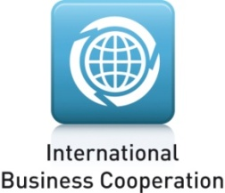 | Category 5: International  Business Cooperation  Part 1: Introduction  (1-2 pages maximum – Arial 11)

Please specify if you have already participated in the European Business Awards for the Environment

Yes No

If yes, please give: Year/s: ________________

Award category/ies: _____________

Title of previous proposal/s: _____________

Please indicate if your company is a Micro, Small, Medium or Large entity (refer to table on page 5 for criteria).

☐ Micro ☐ Small ☐ Medium ☐ Large

Please indicate if your company is Independent, a joint venture or a subsidiary

☐ Independent ☐ Joint Venture ☐ Subsidiary

Please confirm that your company is a business entity with an industrial or commercial character, not a body governed by public law (refer to page 7 of the EBAE handbook for details).

Yes, a business entity No, not a business entity

- What status was the company granted at the national level competition?
Winner
Runner-up
Special recommendation

- Specify one or more sources where this information can be verified (website and/or contact details):

- Title of project or initiative:

- Company name:
(information about the companies involved in the cooperation is to be provided under Part 2 – Application Form – Summary):

- Company Address:

- Country:

- Contact person:

- E-mail:

- Telephone:

- Website:

- Specify if you have included any supporting materials in annex to this entry form:
Yes No

- If yes, please mention the name and the type of the annex/es (CD-ROM, brochure, .pdf document, other):

Annex 1: _______________
Annex 2: _______________

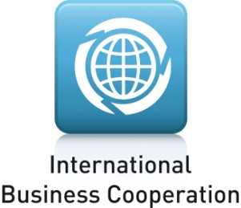
Part 2: Application Form
(4 pages maximum – Arial 11)

Summary (One page maximum)
- Provide a description of the company and a description of the initiative/project submitted, including information on the phase of development (prototype/on the market; pilot/full scale adoption) and a summary of its main benefits and significance. Include information on the companies involved in the cooperation (status, size and geographical location).

Sustainable development objectives
- What are the environmental objectives of the business cooperation and how are these expected to contribute to:
- environmental protection;
- economic development;
- social equity

Planning and resource allocation
- Provide detailed evidence of the agreed plans and available resources to enable the cooperation to achieve its objectives.

Equity
- Provide detailed evidence that the cooperation operates in a way that is fair and transparent to all parties and that the benefits are evenly distributed.

Synergy
- Provide detailed evidence of the ways in which the cooperation has achieved better or greater results than if the partners had worked alone (e.g. did the cooperation lead to avoidance of duplication of efforts and costs?).

Replication potential
- Describe the potential for the business cooperation to be replicated elsewhere (market and geographical scope) and the actions to share the knowledge and expertise with other organisations.

Business and biodiversity
7. Does your business address biodiversity at a management level? Is biodiversity protection included in your business policy and/or strategy and how?
8. Specify if you wish to be automatically considered for the Business and Biodiversity Award. Yes □ No □
9. If you have answered yes to question 8, please answer the following questions:
- Does your activity contribute to the protection of ecosystems/habitats/species or genetic diversity? Otherwise, does your activity contribute to alleviate a relevant pressure on biodiversity? How?
- What is the direct impact of your action on biodiversity and does it also protect and improve biodiversity in a broader context? How?
- How sustainable is it? For example: is biodiversity an added value for your company? Is sustainable financing in place? How is awareness raised with other actors, your value chain and within your company?

COM_(2010) 2020: Communication from the Commission "Europe 2020: a strategy for smart, sustainable and inclusive growth".
COM_(2010) 546: Communication from the Commission: "Europe 2020 Flagship Initiative: Innovation Union".
COM_(2011) 21: Communication from the Commission: "A resource-efficient Europe – Flagship Initiative under the Europe 2020 Strategy".
COM(2015) 614 final Communication form the Commission: “Closing the loop - An EU action plan for the Circular Economy”.
COM_(2011) 899: Communication from the Commission: Innovation for a sustainable Future –The Eco-innovation Action-Plan” (ECO-AP)
International Monetary Fund’s (IMF) World Economic Outlook Report 2010: http://www.imf.org/external/pubs/ft/weo/2010/01/weodata/groups.htm#oem

